**AI ASSISTED CODING**

**LAB-2*: Exploring Additional AI Coding Tools – Gemini (Colab) and Cursor AI***

**Roll no:** 2503A51L07

**Name:** Bathini Sahasra

**Batch:** 25BTCAICSB19

**Task-1 Description:** Open Google Colab and use Google Gemini to generate Python code that performs sorting of a list using both the bubble sort algorithm and Python’s built-in sort() function. Compare the two implementations.

**Prompt:** Python code that performs sorting of a list using both the bubble sort algorithm and Python’s built-in sort() function. Compare the two implementations.

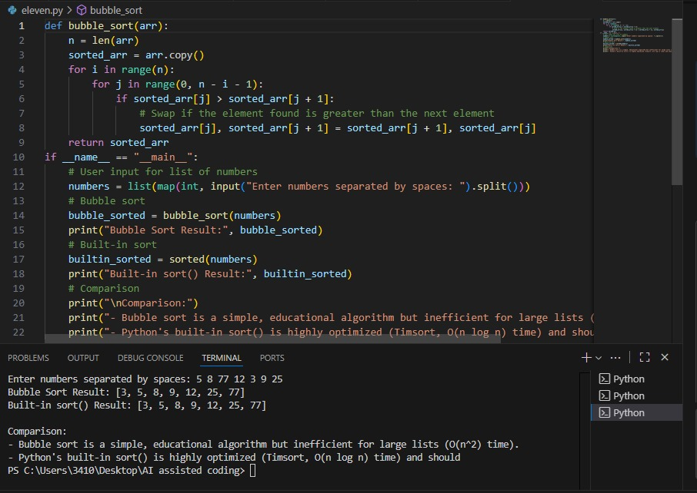**Code Generated:**

**Observation:** In this task, Gemini generated two different sorting implementations: one using the manual Bubble Sort algorithm and the other using Python’s built-in sort() function. This highlighted the difference between a step-by-step algorithmic approach and an optimized built-in method, making it clear that while algorithms are useful for learning, built-in functions provide efficiency in practical use.

**Task-2 Description:** In Colab, use Google Gemini to generate a Python function that takes a string and returns The number of vowels, The number of consonants, The number of digits in the string

**Prompt:** Generate a Python function that takes a string and returns: The number of vowels, The number of consonants, The number of digits in the string

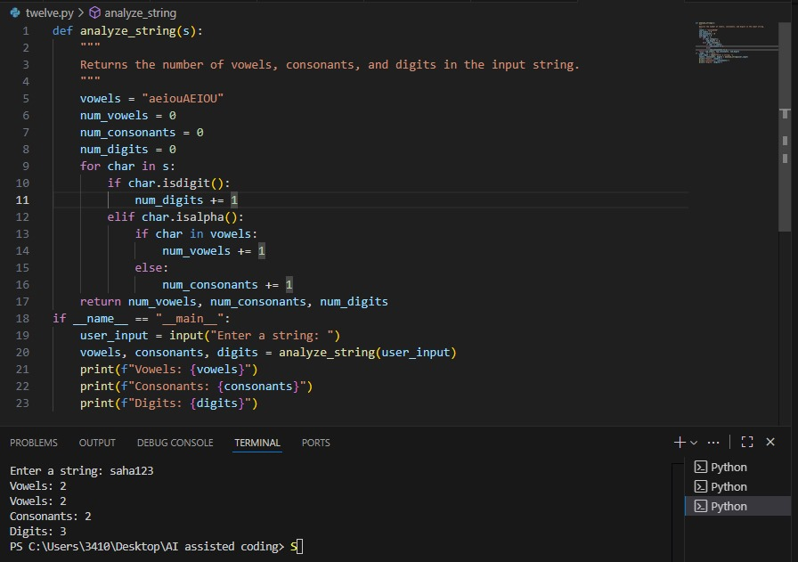**Code Generated:**

**Output:**

**Observation:** In this task,I observed that Gemini was able to implement a function that processes a string and accurately counts vowels, consonants, and digits. This task demonstrated the AI’s ability to handle string manipulation and conditional logic effectively.

**Task-4 Description:** Ask Google Gemini to generate a Python program that implements a simple calculator using functions (add, subtract, multiply, divide). Then, ask Gemini to explain how the code works.

**Prompt:** Generate a Python program that implements a simple calculator using functions (add, subtract, multiply, divide).And explain the code.

**Code Generated: 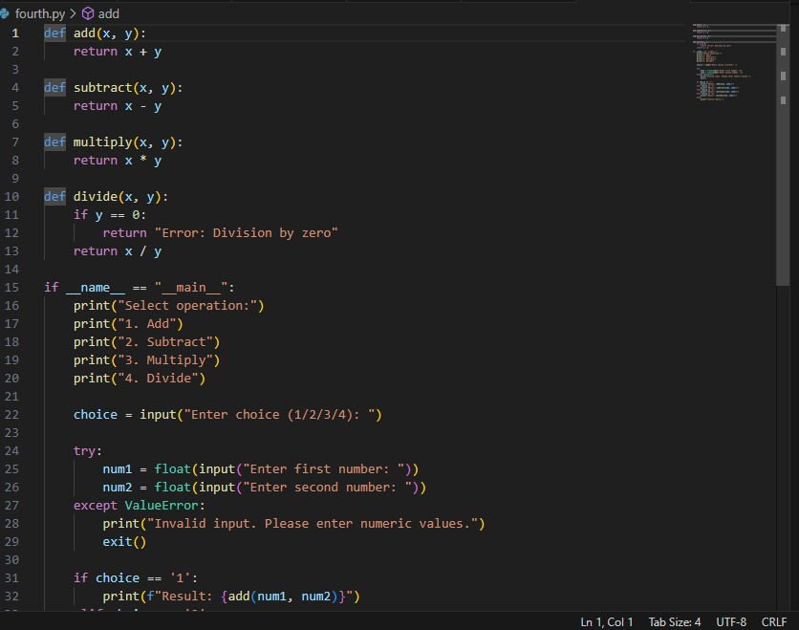Output:**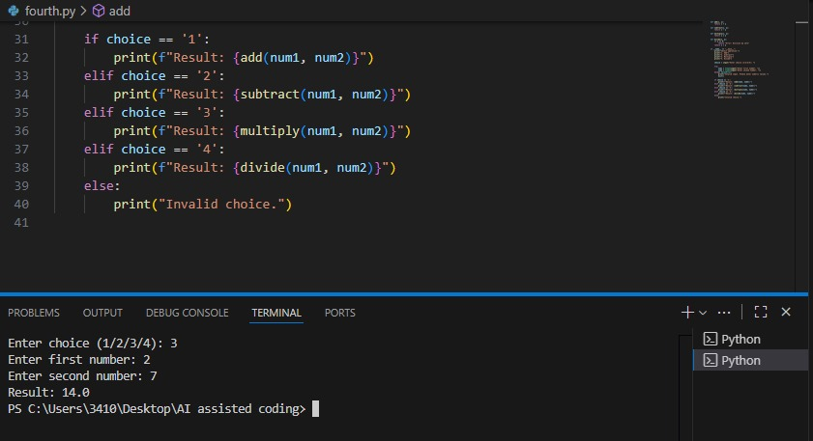

**Observation:** In this task,Gemini successfully generated a program for a

simple calculator using functions for addition, subtraction, multiplication, and division. More importantly, when asked to explain the code, it provided a step-by-step breakdown, showing how AI can assist not only in code generation but also in teaching and concept explanation.